**Learning Outcomes**

1. Understanding Local database on Android using SQLite

**SQLite**

SQLite is a software library that implements a [self-contained](http://www.sqlite.org/selfcontained.html), [serverless](http://www.sqlite.org/serverless.html), [zero configuration](http://www.sqlite.org/zeroconf.html), [transactional](http://www.sqlite.org/transactional.html) SQL database engine.

SQLite is the [most widely deployed](http://www.sqlite.org/mostdeployed.html) SQL database engine in the world. The source code for SQLite is in the [public domain](http://www.sqlite.org/copyright.html).

**Creating a Local database using SQLite Manager**

**SQLite Manager**

Search for the SQLite Manager plug-in in the Add-Ons in Mozilla Firefox

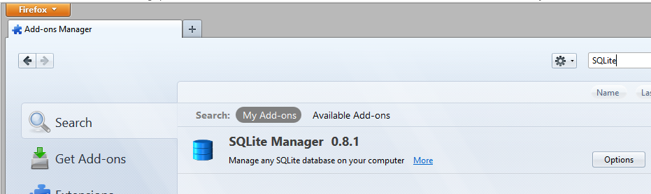

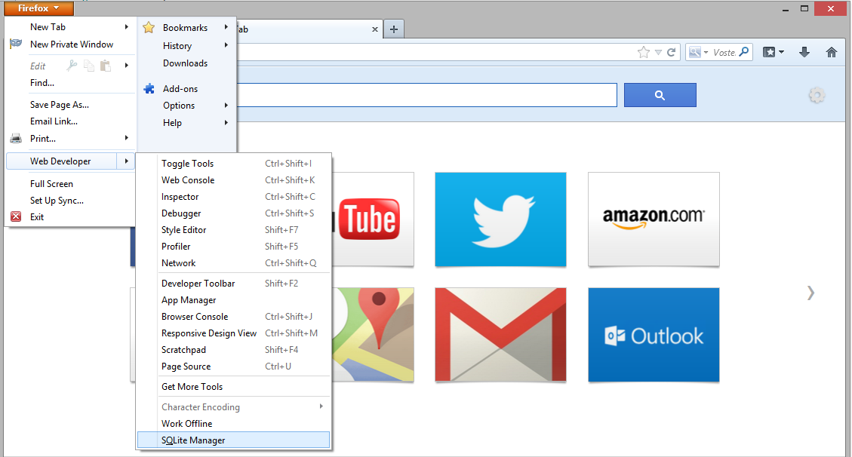

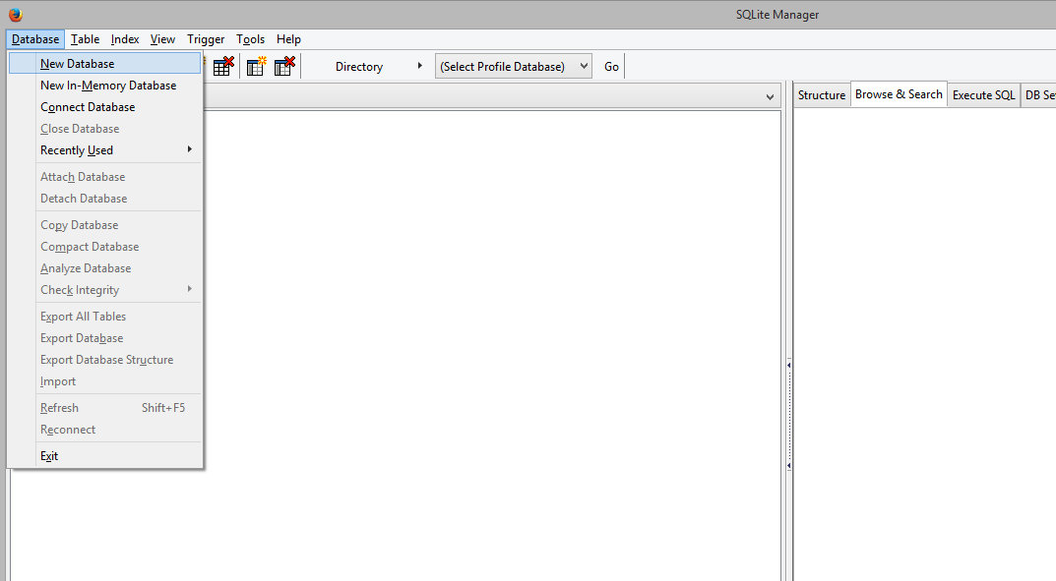

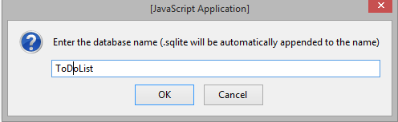

**Create a table as shown below.**

**Add a record**

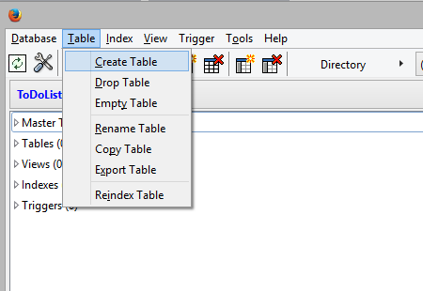

**Name the table tblToDoList**

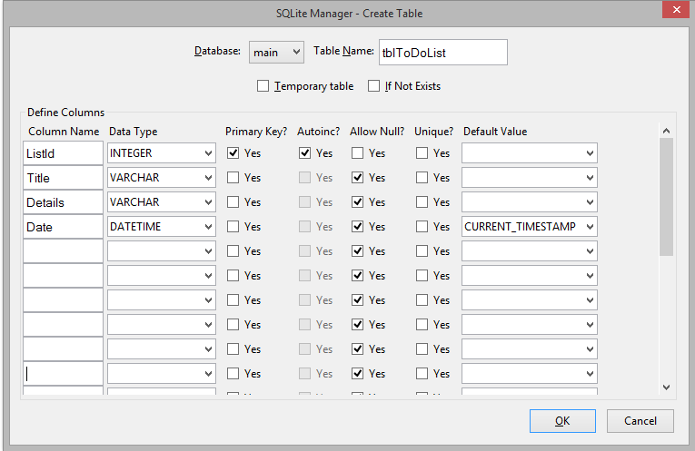

To add a record click on the Add button.

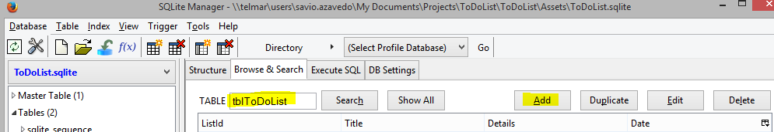

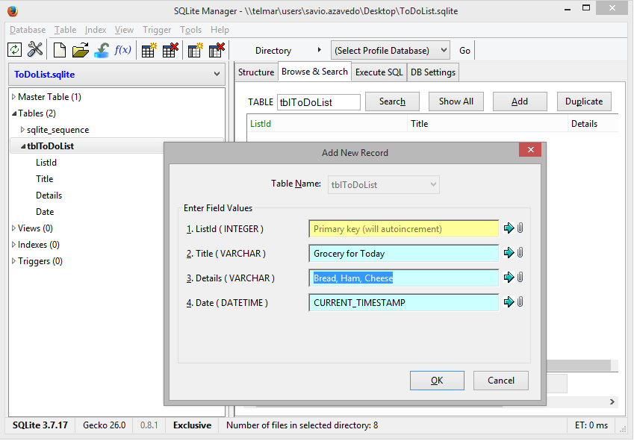

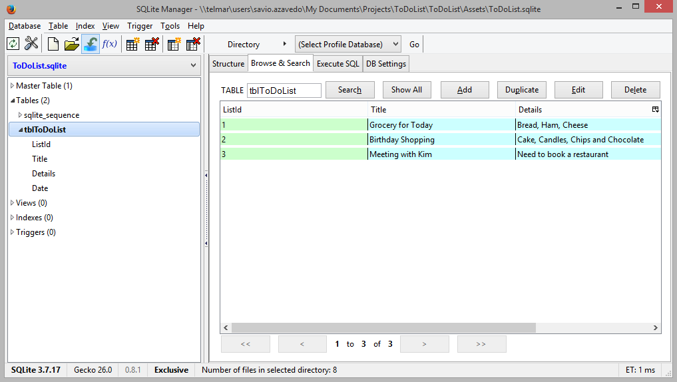

Add ToDoList.sqlite to your assets folder

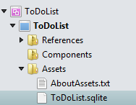

**Permissions required**

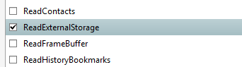

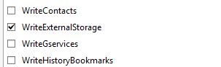

**Create Two layout files main.axml and Custom_Row.axml**

**Designing Custom_Row.xml**

<?xml version="1.0" encoding="utf-8"?>  
<RelativeLayout xmlns:android="http://schemas.android.com/apk/res/android"  
    android:layout_width="fill_parent"  
    android:layout_height="wrap_content"  
    android:orientation="vertical"  
    android:padding="5dip"  
    android:background="#ffffffff">  
<!-- SQLite row id / hidden by default -->  
    <TextView  
        android:id="@+id/sqlite_id"  
        android:layout_width="wrap_content"  
        android:layout_height="wrap_content"  
        android:visibility="gone" />  
<!-- web site title -->  
    <TextView  
        android:id="@+id/title"  
        android:layout_width="fill_parent"  
        android:layout_height="wrap_content"  
        android:paddingTop="8dip"  
        android:paddingLeft="8dip"  
        android:paddingBottom="4dip"  
        android:textSize="18dip"  
        android:text="Your Heading will appear here"  
        android:textColor="#ff2b53e4" />  
<!-- web site url -->  
    <TextView  
        android:id="@+id/link"  
        android:layout_height="wrap_content"  
        android:layout_width="wrap_content"  
        android:paddingLeft="8dip"  
        android:paddingBottom="6dip"  
        android:textSize="15dip"  
        android:text="Your Sub-Heading"  
        android:textColor="#ff000003"  
        android:layout_below="@id/title" />  
<!-- Right end Arrow -->  
    <ImageView  
        android:layout_width="wrap_content"  
        android:layout_height="wrap_content"  
        android:src="@drawable/arrow"  
        android:layout_alignParentRight="true"  
        android:layout_centerVertical="true" />  
</RelativeLayout>

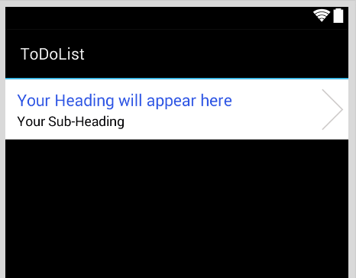

**Main.axml**

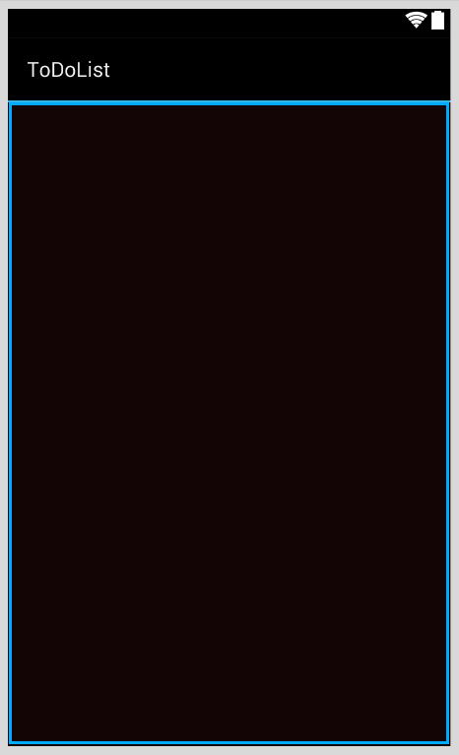

ListView

Width and Height set to fill_parent

**Add a new class**

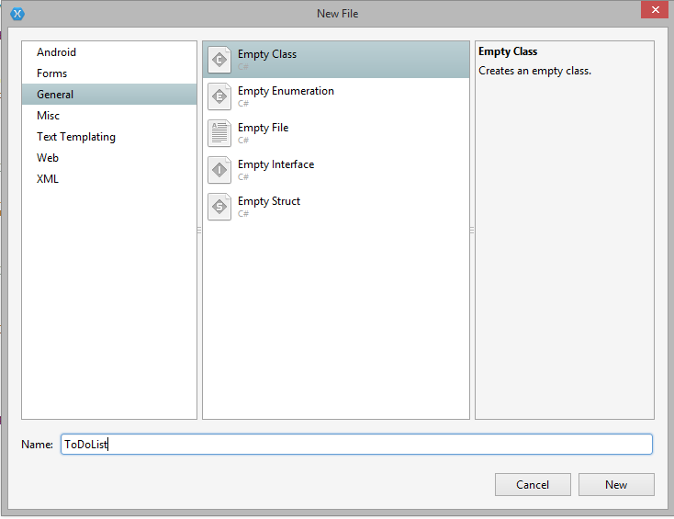

**ToDo.cs**

Create a new class name itToDo

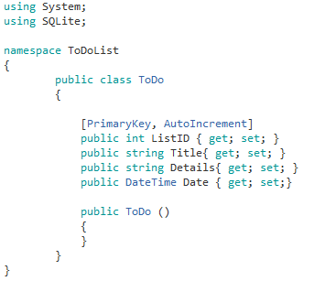

Add the Files **DataAdapter.cs** and **Sqlite.cs**

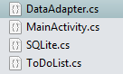

**DataAdapter.cs (Copy Paste)**

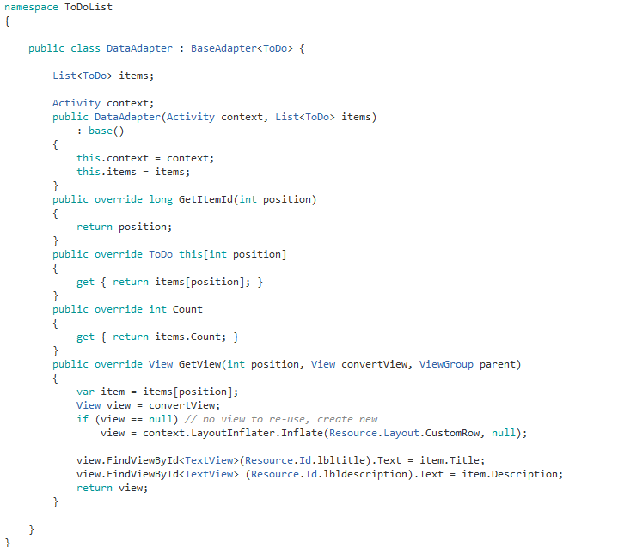

**Create a new class file DatabaseManager.cs**

**DatabaseManager.cs**

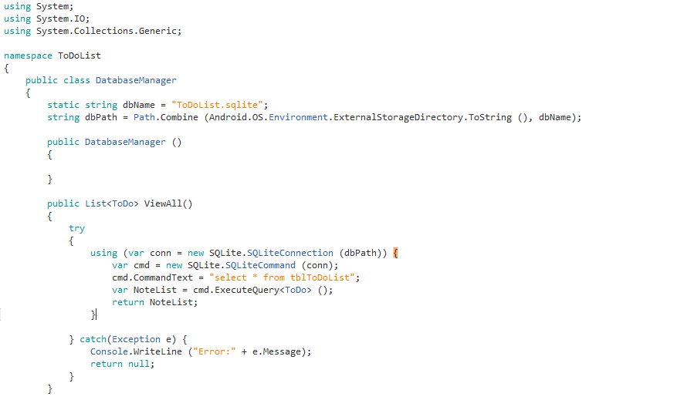

**MainActivity.cs**

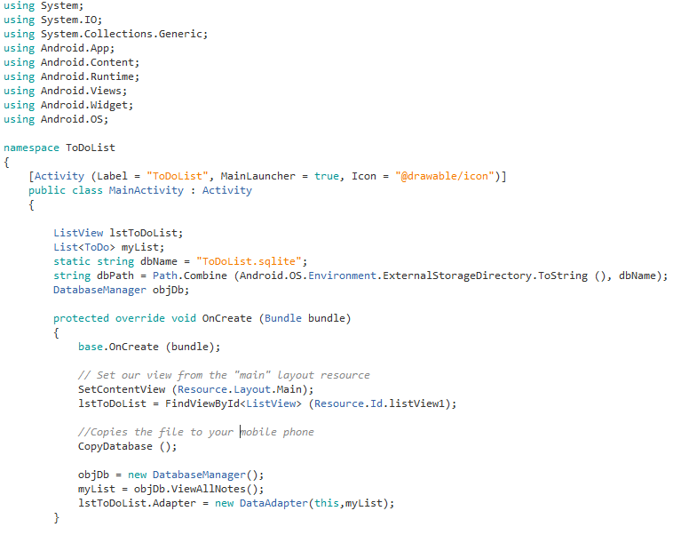

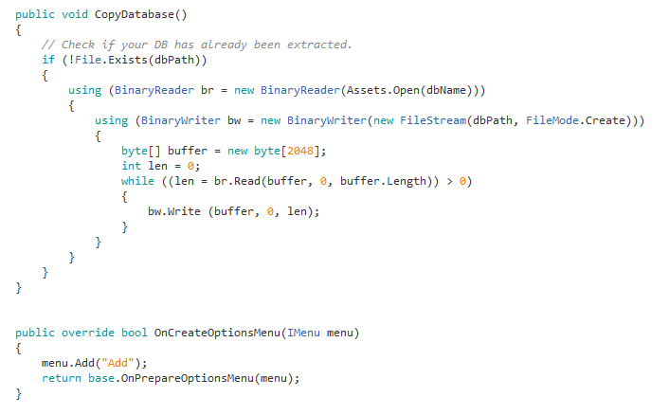

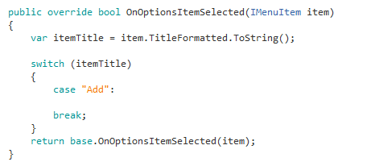

**Run the code to find the following added.**

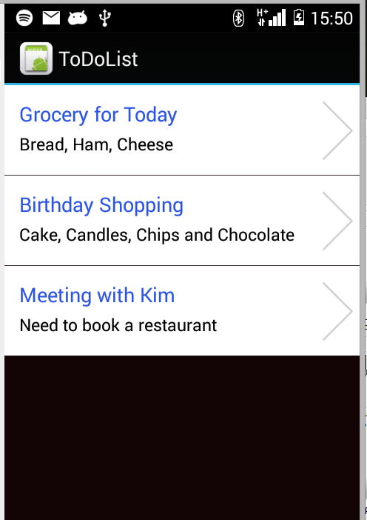

**Exercise**

On the click event of the list view open up another activity and show the details of the To-Do-List